ITT – PYTHON PROGRAMMING – INTERNAL_2 EXAMINATION

Question:1:
  - amount = float(input("Enter the total shopping amount: "))
  - if amount > 5000:
  - discount = 0.20
  - elif 3000 <= amount <= 5000:
  - discount = 0.10
  - else:
  - discount = 0.00
  - discount_amount = amount * discount
  - final_amount = amount - discount_amount
  - print(f"Discount applied: {discount * 100}%")
  - print(f"Discount amount: {discount_amount}")
  - print(f"Final amount to pay: {final_amount}")

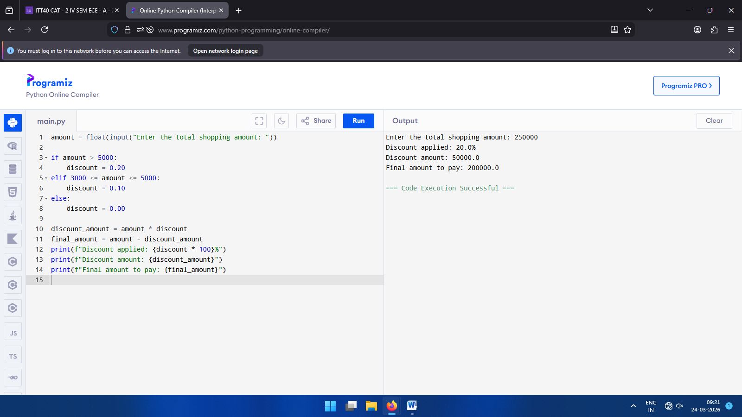
(Qn_1: Program Code and its Output)

Question:2:

  - def solve_robot_moves():
  - print("--- Robot Grid Navigation ---")
  - try:
  - sx, sy = map(int, input("Enter Start Position (row col): ").split())
  - ex, ey = map(int, input("Enter End Position (row col): ").split())
  - except ValueError:
  - print("Error: Please enter two numbers separated by a space (e.g., '1 1').")
  - return
  - if sx == ex and sy == ey:
  - moves = 0
  - explanation = "Start and End are the same."
  - elif sx != ex and sy != ey:
  - moves = 1
  - explanation = "Both Row and Column are different. Direct move possible."
  - else:
  - moves = 2
  - explanation = "Shared Row or Column. Must pivot to an intermediate square."

  - print(f"\nMinimum Moves Required: {moves}")
  - print(f"Reason: {explanation}")

  - solve_robot_moves()

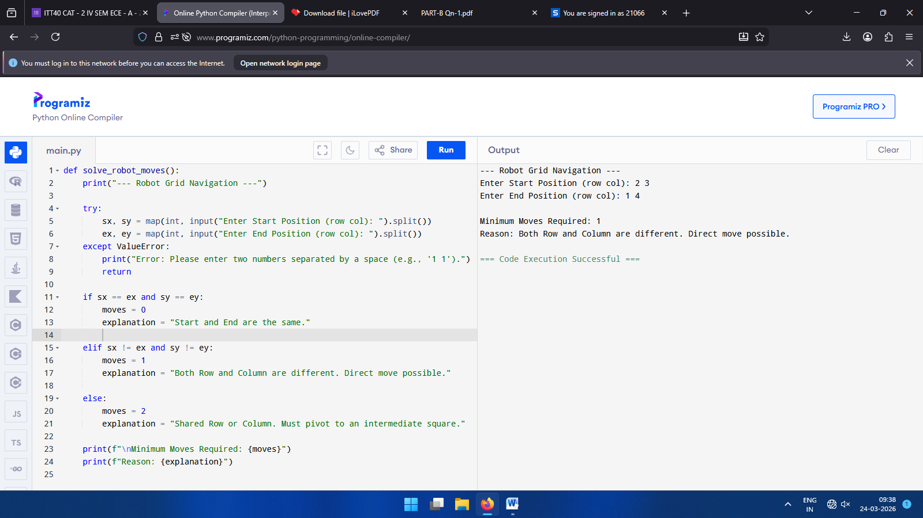

Qn_2: case (i) – When start and end positions are different

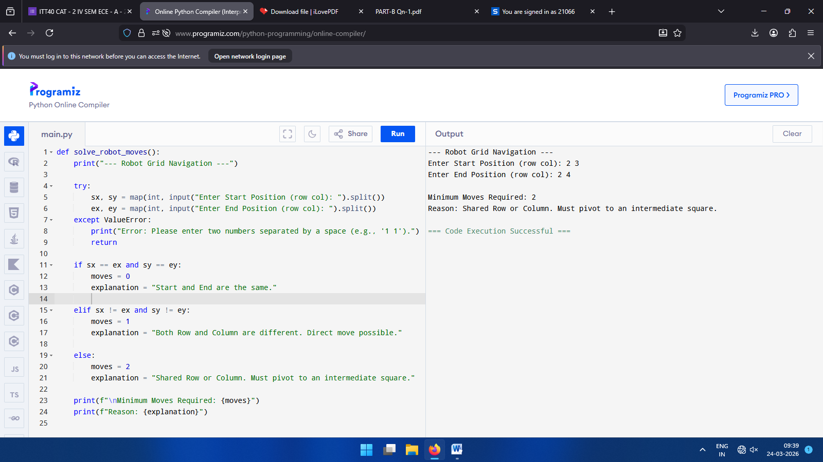Case (ii): - When any one of the positions is same

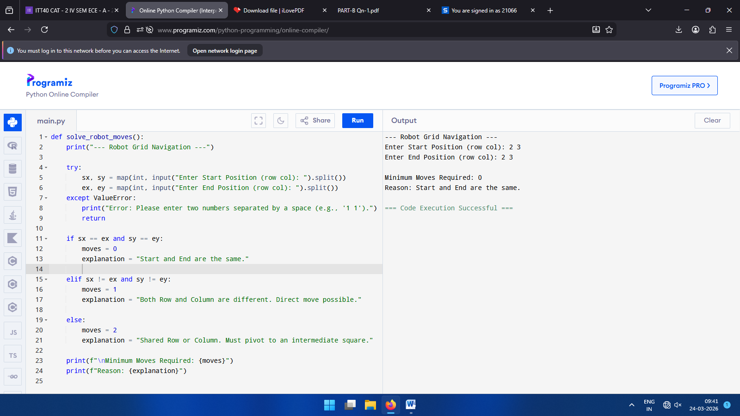

Case (iii) : - When both start and end positions are same

SUBMITTED BY:
NAME : ELZY HEPHZIBAH G
ROLL_NO : 24BEC008
CLASS : IInd YEAR – ECE_’A’

